**Task 3:-**

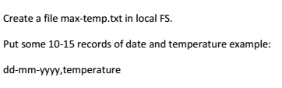

**Explanation:-**

Using the below command (cat >max-tmp.txt), new file will be created called **max-temp.txt** in the working directory. After created, we have to enter the desired text to store in the file named **max-temp.txt** and press Ctrl+D to store it.

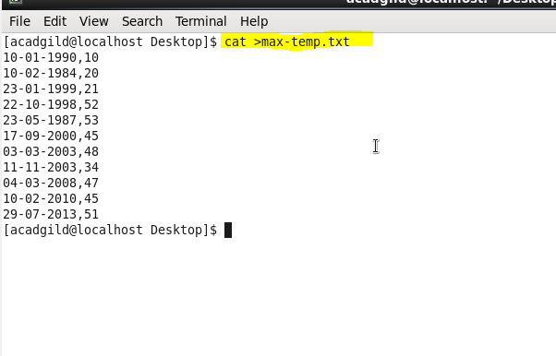

As shown in the above screenshot, 10 entries of date and temperature are entered and pressed Ctrl+D to store it in the file named **max-tmp.txt**.

Those entered 10 entries are stored in the file named **max-temp.txt** as shown in below screenshot.

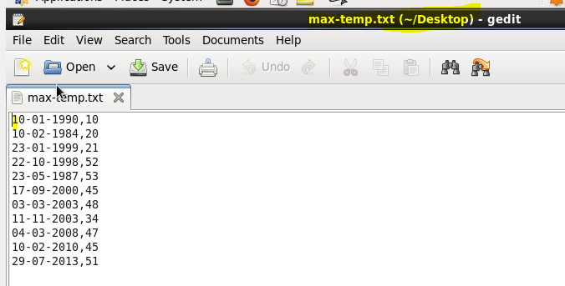

Now we can copy the file named **max-temp.txt** under **/home/acadgild/Desktop** directory in local File System to HDFS using **put** command under the specified directory **/user/acadgild/hadoop.**

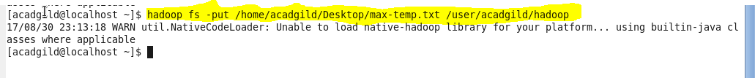

Now I have listed the files under **/user/acadgild/hadoop** in HDFS below. In the below screenshot, you can see the moved file named **max-temp.txt.**

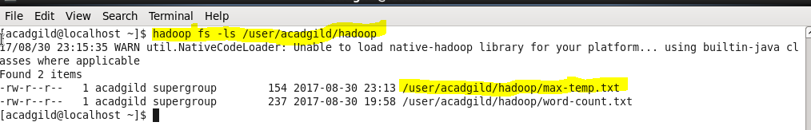

Now I have displayed the file named **max-temp.txt under HDFS** in the below screenshot**.**

